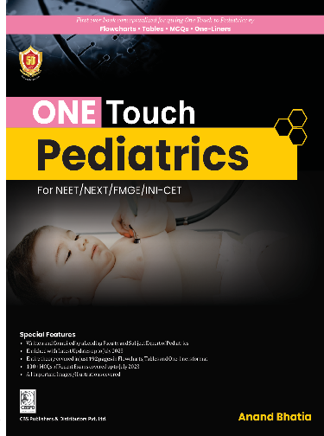
CBS PUBLISHING

ONE TOUCH Pediatric

for NEET/NEXT/FMGE/INI-CET

Editor by: Dr Anand Bhatia
ISBN: 9789394525351 Year: 2024 Pub.: CBS Pages: 188
Binding: Paperback Price: Rs. 450.00

About The Book
- Written and Compiled by a Leading Faculty and Subject Expert of Pediatrics
- Enriched with Latest Updates up to July 2023
- Entire theory covered in just 192 pages in Flowcharts, Tables and One-liners format
- 100+ MCQs of Recent Exams covered up to July 2023
- All important Images/Illustrations covered
Salient Features
- Theory—A concise form of text covered in just 192 pages and most important points to remember are given for the last-minute revision. Throughout the book text is presented in the form of Tables, Boxes, Flowcharts, and Illustrations for easy recalling.
- High-Yield Tables—Frequently asked Topics and clinical correlations are tabulated for ease of learning and more visual impact for long-term memory.
- Clinical Images and Illustrations—Clinical Images and Illustrations have been supplemented with the text for better and easy understanding of the concepts.
- Previous Years Qs—Important Topics/Qs have been highlighted in-between the text for a quick glance over the important topics from exam point of view/questions have been asked from the respective topic in previous year examination.
- Recent Questions—Last 3 years' exam question papers up to (July 2023) are provided to develop an idea about the trend of questions and also to know about the recently asked topics.

About The Author
Anand Bhatia MBBS MD (Pediatrics) is one of the youngest Pediatricians who has made his presence felt in the entire nation in a short span of time. He has done his MBBS from Dr. B.R. Ambedkar Medical College, Bangalore, Karnataka. He pursued his MD Pediatrics from Teerthanker Mahaveer University, Moradabad, Uttar Pradesh. He has a wonderful teaching experience of 7 years and is currently working as Assistant Professor in N.D.M.C. Medical College, Hindu Rao Hospital, New Delhi. Pediatrics has always been a loving & caring branch and Dr Anand has justified it by his exemplary services to this branch of medicine.
He has changed the way of teaching by introducing real case scenario or clinical teaching and video-based learning which is new creation in the history of mankind. The only genuine intention of creating this book is to give an authentic knowledge of learning in the field of Pediatrics. Give your best & destiny will do the rest is the motto of the author.

Contents

Preface v
THEORY
- Growth and Development 3
- Neonatology 20
- Respiratory System 40
- Pediatric Cardiology 49
- Behavioral Disorders 60
- Central Nervous System 62
- Immune System 79
- Breastfeeding 84
- Severe Acute Malnutrition 86
- Micronutrients 90
- Vaccines 95
- Hematology and Infectious Disease 99
- Renal System 111
- Musculoskeletal System 115
- GIT/Hepatology 121
- Inborn Errors of Metabolism 128
- 100 Images 138
NEET 2023-2021 157
LATEST QUESTION PAPERS
INI-CET 2023-2021 163
FMGE 2023 (July and January) 170
FMGE 2022 173

